Artificial Intelligence Sem 1 2019

COMP717

Assignment 2: Fuzzy Logic Controller

Zeting Luo 16938158

Submit date: 31/May/2019

Contents

Abstract 2

Introduction 2

Problem define: Why do we need fuzzy logic controller on washing machines? 2

Fuzzy logic controller architecture 2

Detail of the set applied 3

Fuzzifier 3

Rules 3

About ‘and’ operator and ‘or’ operator: 3

Defuzzifier and output 3

Surface 4

About rules view and sample outputs 4

About more input - Temperature of water 4

New input variable 4

New rules 5

New surface 5

New sample output 5

About the fifth variable – Amount of detergent 6

New input variable 6

New rules: 6

New surface 6

Simple output 6

Summery 6

# Abstract

Fuzzy logic is a way to computing value base on “degrees of the factor”, it is different to usual programing “Boolean” can only store true or false, so that fuzzy controller can take care different input factors. This report describes the procedure that can be used to get a suitable washing time for different dirtiness, dirty types, and other variables. The process is based on washing machine sensors give input to fuzzy logic controller and calculate a clear value washing time.

# Introduction

This is a report for assignment 2 of Artificial Intelligence. This report is about fuzzy logic controller of a washing machine.

In this report, fuzzy logic controller is going to control a washing machine to calculate correct washing time base on the condition of the clothes.

The architecture of the washing machine fuzzy logic controller is based on the dirtiness of the clothes and the type of the dirt of the clothes. Basically, dirtier will cause longer washing time. Also, more inputs will add into the controller, this will be discussing more detailly in the report.

# Problem define: Why do we need fuzzy logic controller on washing machines?

Reason can be simple, it is because washing machine does not like real human, if no fuzzy logic implemented, it will only be switch on or off, and wash all type of clothes in a fixed time with no matter how dirty they are. One of the characteristics of fuzzy logic can take care multiple type of input and calculate output by “degrees of the factor”. So that implement fuzzy logic on controller can make washing machine take care different types of clothes conditions (e.g. dirtiness, types of the dirt), by this way washing machine can be smarter and working more like a human thinking.

# Fuzzy logic controller architecture

The architecture of the fuzzy logic controller is shown in figure 1.

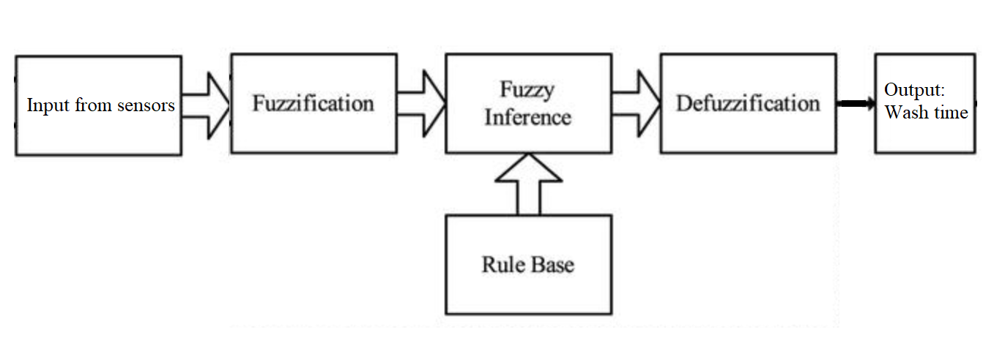

Figure 1 basic architecture of fuzzy logic controller

Fuzzy logic controller will process the information given by the sensors on the machine and calculate an output of wash time. (Detail on how it works is discussed on the report other parts)

There are two type of data should be input

1. Degree of dirty
2. Type of dirty

Degree of dirty data can be read from the washing machine sensors by scan the dirt partials on the clothes, more dirt partials means dirtier.

Type of dirty will be determined by time of water get dirty, longer time means greasier (greasy is harder to dissolve).

After user put clothes into the washing machine and water added to the machine, there are will be a time that sensors get stable data reading. At this time, machine will begin to calculate the output wash time.

# Detail of the set applied

## Fuzzifier

Fuzzifier is a process to convert clear input value into a fuzzy value, in first, there are only two variables input so that there are two membership functions user to map input to fuzzy value.

Figure 2 shows membership function of DegreeOfDirty with range 0 to 100 unit: percentage

Figure 3 shows membership function of TypeOfDirty with range 0 to 100 unit: percentage

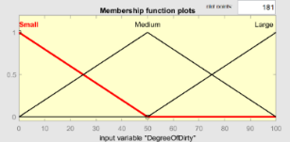 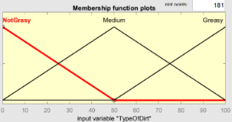

Figure 2 Membership function:DegreeOfDirty Figure 3 Membership function: TypeOfDirt

For example: If now has input 10 to membership function DegreeOfDirty, fuzzy output can be ‘Small’

## Rules

Rules are how the decisions made by fuzzy controller, there stored in knowledge database. In high level understand, rules are if-then statement and it is based on input variables, and easy to understand.

Rules that used in this report is based on the sense of more dirty takes longer and greasier takes longer, and their listed in table 1 down below.

Table 1 Rules: two input type

|  |
| --- |
| If (DegreeOfDirty is Large) and (TypeOfDirt is Greasy) then (WashTime is VeryLong) |
| If (DegreeOfDirty is Medium) and (TypeOfDirt is Greasy) then (WashTime is Long) |
| If (DegreeOfDirty is Small) and (TypeOfDirt is Greasy) then (WashTime is Long) |
| If (DegreeOfDirty is Large) and (TypeOfDirt is Medium) then (WashTime is Long) |
| If (DegreeOfDirty is Medium) and (TypeOfDirt is Medium) then (WashTime is Medium) |
| If (DegreeOfDirty is Small) and (TypeOfDirt is Medium) then (WashTime is Medium) |
| If (DegreeOfDirty is Large) and (TypeOfDirt is NotGrasy) then (WashTime is Medium) |
| If (DegreeOfDirty is Medium) and (TypeOfDirt is NotGrasy) then (WashTime is Short) |
| If (DegreeOfDirty is Small) and (TypeOfDirt is NotGrasy) then (WashTime is VeryShort) |

### About ‘and’ operator and ‘or’ operator:

‘and’ operator: The ‘and’ operator will take the lower value of member functions

‘or’ operator: The ‘or’ operator will take the higher value of the member functions

## Defuzzifier and output

After apply rule, fuzzy controller will have a bit clearer value to do the defuzzy processes. A membership function will cover the output and help defuzzy the value back to normalized clear value. Output membership function of wash time shown down below at figure 4.

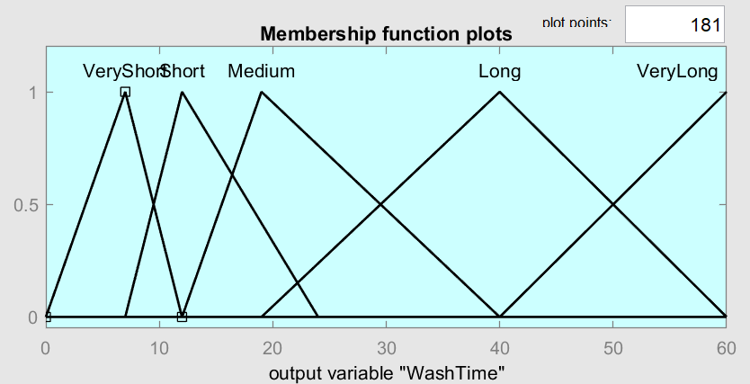

Figure 4 Output membership function:WashTime

After apply rule, fuzzy logic controller interprets fuzzy values as weightings. For example, 0.3 times of Medium and 0.4 times of long, wash time can be calculated by (3*medium+4*long)/7.

At last, a clear value will be output as answer of wash time as a clear value between 0 to 60 minutes.

## Surface

By using the method above, inputs values from sensors can be fuzzified and apply rules (including operators) than using the output membership function, we can get a clear output wash time.,

Output of wash time of different conditions can be representing by a response surface shown down below at figure 5.

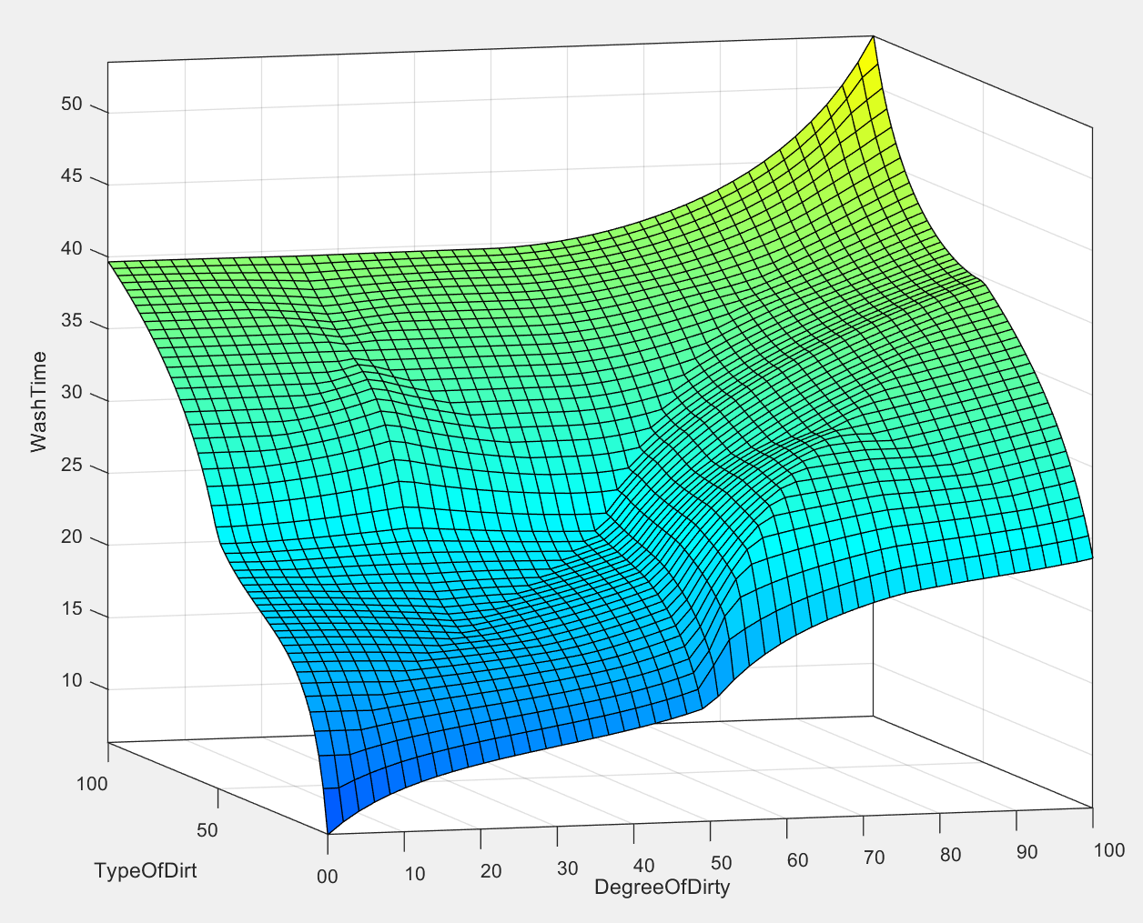 



Figure 5 surface of the output Figure 6 surface with discontinue indication

We can see there are some discontinue on the surface (figure 6), but its gradient does not change a lot. Since this output is wash time, discontinues does not affect user experience a lot because every single time of wash is independent, user is very hard to feel this little be discontinue.

## About rules view and sample outputs

By use the rules view (figure 7) in MATLAB, we can find out that for dirtiness = 70 and type of dirty = 50 wash time is 33, dirtiness = 0 and type of dirty = 50 wash time is 23.7, dirtiness = 100 and type of dirty = 100 wash time is 53.5. When there is 100% greasy, the minimum length of wash time is 40, when there is 100% dirty the minimum length of wash time is 23.7.

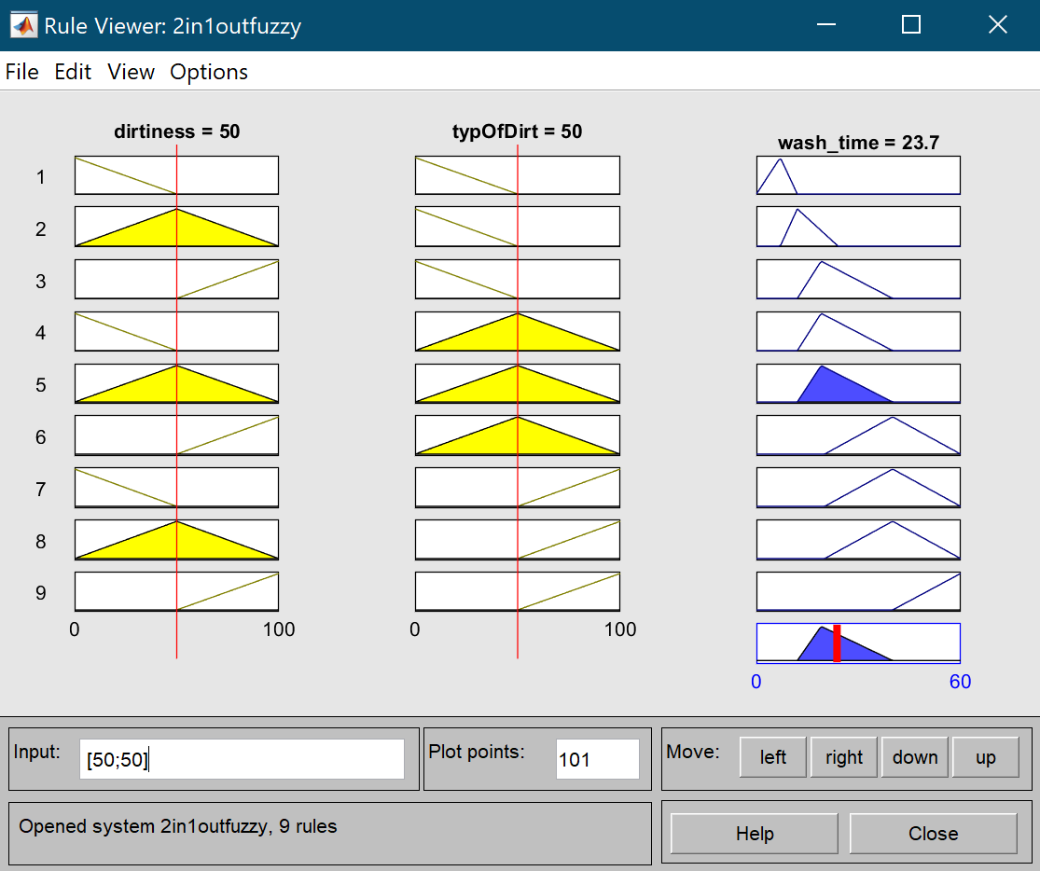

Figure 7 rule view

# About more input - Temperature of water

At current stage, the fuzzy controller already able to obtain a wash time for different type of dirt and different degree of dirt. But in real life, there are more factors able to affect wash time. More input means fuzzy logic controller takes more to calculation, so it is more human like and intelligent. We can add one more input into the system, that is temperature of water.

Temperature of water can be input from washing machine water temperature sensors. Higher temperature of water can make greasy dissolve more quickly and cooler water make greasy dissolve harder. So that higher water temperature can lower down the wash time, and lower temperature will make wash longer.

## New input variable

Figure 8 shows membership function of TemperatureOfWater with range 20 to 60 unit: °C

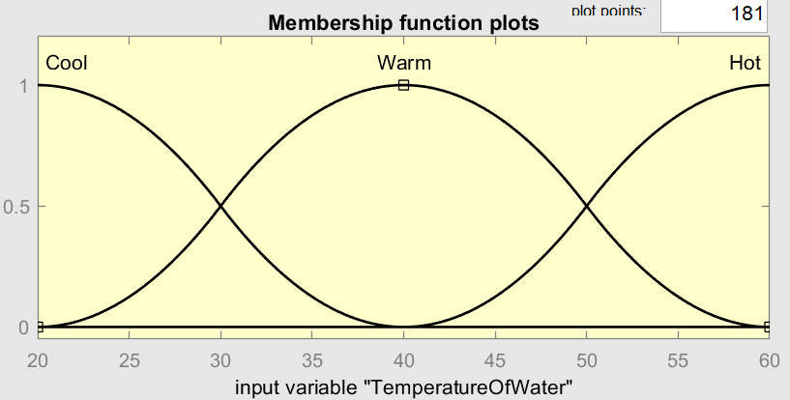

Figure 8 Membership function:TemperatureOfWater

## New rules

Base on the senesce of hotter water dissolve greasy is easier, some rules is adding to the fuzzy logic controller. Rules are list down below on table 2.

Table 2 new rules

|  |
| --- |
| If (TypeOfDirt is Greasy) and (TemperatureOfWater is Hot) then (WashTime is Medium) |
| If (TypeOfDirt is Greasy) and (TemperatureOfWater is Warm) then (WashTime is Long) |
| If (TypeOfDirt is Greasy) and (TemperatureOfWater is Cool) then (WashTime is Long) |
| If (TypeOfDirt is Medium) and (TemperatureOfWater is Hot) then (WashTime is Short) |
| If (TypeOfDirt is Medium) and (TemperatureOfWater is Warm) then (WashTime is Medium) |
| If (TypeOfDirt is Medium) and (TemperatureOfWater is Warm) then (WashTime is Long) |
| If (TypeOfDirt is NotGrasy) and (TemperatureOfWater is Hot) then (WashTime is VeryShort) |
| If (TypeOfDirt is NotGrasy) and (TemperatureOfWater is Warm) then (WashTime is Short) |
| If (TypeOfDirt is NotGrasy) and (TemperatureOfWater is Cool) then (WashTime is Medium) |
| If (DegreeOfDirty is Small) or (TypeOfDirt is NotGrasy) or (TemperatureOfWater is Hot) then (WashTime is VeryShort) |
| If (TypeOfDirt is Greasy) and (TemperatureOfWater is not Hot) then (WashTime is VeryLong) |
| If (DegreeOfDirty is not Small) or (TypeOfDirt is Greasy) or (TemperatureOfWater is Hot) then (WashTime is Short) |
| If (DegreeOfDirty is Large) and (TypeOfDirt is Greasy) and (TemperatureOfWater is Hot) then (WashTime is Long) |
| If (DegreeOfDirty is Small) and (TypeOfDirt is Greasy) and (TemperatureOfWater is Hot) then (WashTime is Medium) |

## New surface

After added the rules, we can check the surface again, but because 3d surface can only display two variables at a time, so we show and display two surfaces one by one.

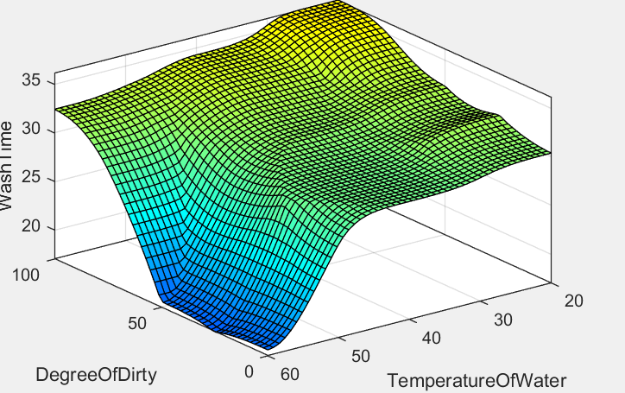 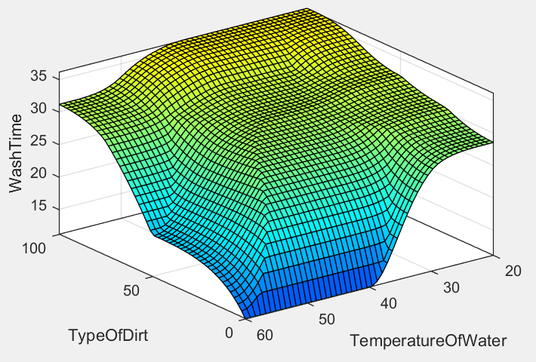

Figure 9 surface:Dirtiness with Teamperature Figure 10 surface :TypeOfDirt with Teamperature

New surface 1: DegreeOfDirty with TeamperatureOfWater, surface shown at figure 9

we can see on the surface, water temperature does not have a huge impact on degree of dirty, it makes senses because brush away dirt dependent on flow of the water but not the temperature of water.

New surface 2: TypeOfDirt with TeamperatureOfWater, surface shown at figure 10

we can see on the surface, water temperature does affect have on the wash time, it makes senses because dissolve greasy is highly dependence on temperature. On the surface, we can see that higher temperature has a lower wash time.

On both surfaces, we can see there some discontinue, but it is not huge gradient change over all is smooth. Also, as this report mentioned above that for users each wash is independent, so that this discontinues show now affect user experiment by a lot.

## New sample output

By use the rules view in MATLAB, we can find out that when there are maximum dirtiness and maximum greasiness, hottest water, water time will be 31.2, when maximum dirtiness and maximum greasiness, coolest water, water time will be 36.2. So, we can see that over all that is about 10% of washing time can be affect by temperature of water.

# About the fifth variable – Amount of detergent

Some users will add detergent into the washing machines, and it will help the washing machine wash the clothes. So that the amount of detergent will affect the wash time as well. The fifth variable for the fuzzy logic controller is the amount of detergent.

## New input variable

Figure 11 shows membership function of amount of detergent with range 0 to 200 unit:ml

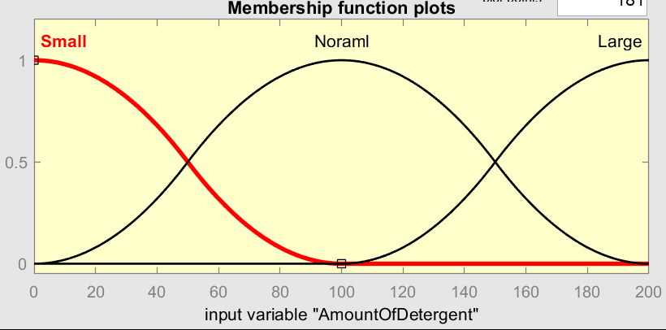

Figure 11 Membership function:TemperatureOfWater

## New rules:

Base on the senesce of more detergent can make wash easier, some new rules is added to the controller, there are listed on table 3 down below.

Table 3 new rules - detergent

|  |
| --- |
| If (TypeOfDirt is Greasy) and (AmountOfDetergent is Large) then (WashTime is Medium) |
| If (DegreeOfDirty is Large) and (TypeOfDirt is Greasy) and (TemperatureOfWater is Hot) and (AmountOfDetergent is Noraml) then (WashTime is VeryShort) |
| If (DegreeOfDirty is Medium) and (AmountOfDetergent is Small) then (WashTime is VeryShort) |
| If (TypeOfDirt is Medium) and (AmountOfDetergent is Small) then (WashTime is VeryShort) |

## New surface

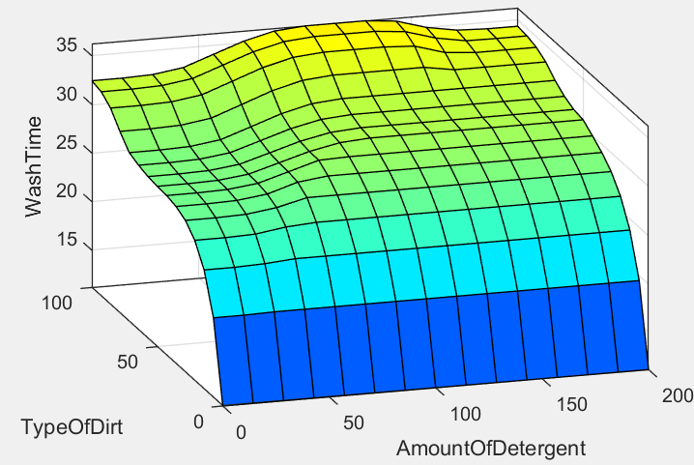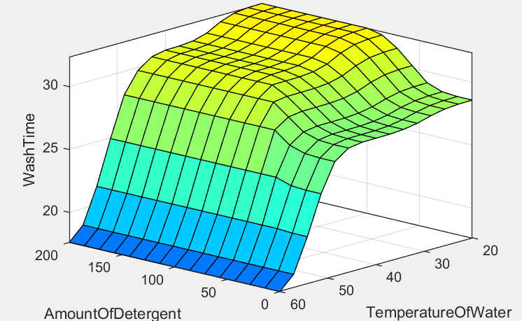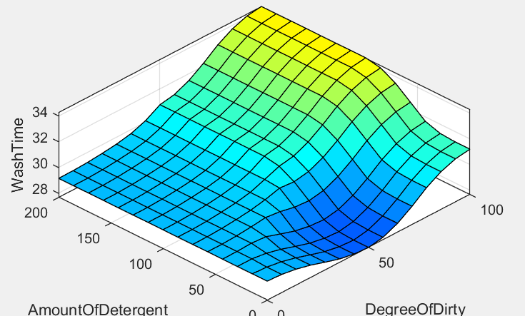

Figure 12 surface:Detergent with other variable

We can see all surface has discontinue, and majorly amount of detergent and amount of dirty affect the time of wash. But it is still no huge change of gradient change on the surface.

## Simple output

By use the rules view in MATLAB, we can find out that when there are maximum dirtiness and maximum greasiness, hottest water and largest amount of detergent, water time will be 31, for there are maximum dirtiness and maximum greasiness, hottest water and smallest amount of detergent, water time will be 31.2. There is no much difference.

# Summery

Using fuzzy logic controller, washing machine able take care of different types of input including type of dirt, amount of dirty, ttemperature of water and amount of detergent, finally it output a reason able wash time. Add more variable to the controller we can see it take care each variable more evenly. In a traditional view, all variable above will be taking care by human, but we can see by use the fuzzy logic controller wash machine can operate more like human and more intelligent. Fuzzy logic controller gives the ability to make design the wash time so the machine much more automatic. This report is very short and not able to cover more inputs and situations, but we can already able to see the advantage of the fuzzy logic controller. If I can do this assignment again, I want I can put more input to the controller, more input means give to the washing machine, so that the washing machine can become even more smart.